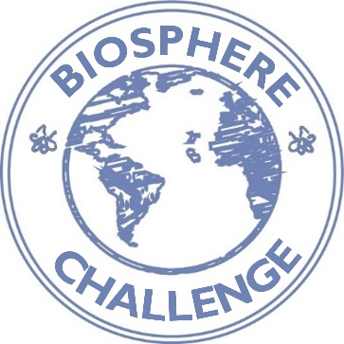
Biosphere Challenge 2016 - Report

Name of the game:

We created this game:
Please indicate which class and the teacher/s responsible.

The name of the school:

The name of your Biosphere Reserve

We created our game by choosing the following criteria (please indicate three):
Our game has part of its origin in another country

Our game has part of its origin in a different time

The whole class can participate simultaneously
The game teaches us about nature

The game trains us to be considerate to each other

The game provides an added value to the schoolyard or the place where the game is played.

More information about our game (Please mark one or more options):
Our game is based on what we can find in our school yard
Our game is based on what we can find in our forest.

Our game requires a ball or other gadget
In this game, we chase each other
Our game is a dance
Other type of game

What is the goal of the game?
Please write who is the winner of the game and why.

Rules
What are the rules of the game? Describe so that others can understand and play your game. If you want, you can use pictures to explain.

Pictures of our class when playing the game
Insert pictures to help others to understand and play the game.

